A000-Afr-Burkina Faso-Mossi-Mask-Yatenga Style-20th c

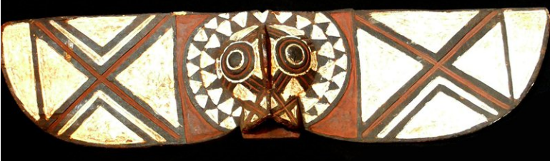 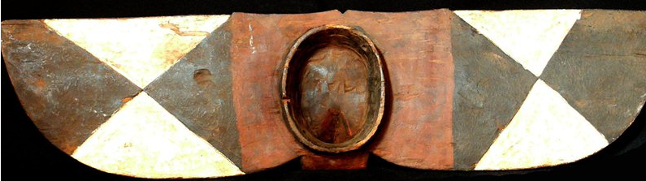

Afr-Burkina Faso-Mossi-Mask-Yatenga Style-20th c

Case No.: 6

**Accession No.**

**Formal Label:** Afr-Burkina Faso-Mossi-Mask-Yatenga Style-20th c

**Display Description:**

The geographical area in which the Yatenga style masks are concentrated is the section of Mossi country to the north of the low,   
swampy area around Nyessega and the Kourougui River, which flows west to east halfway between Yako and Gourcy, and to the   
west of the border between Yatenga and the kingdoms of Zitenga and Risiam. This is the general area of the Mossi kingdom of   
Yatenga (see map).  
  
The range of this Yatenga style also extends to a few scattered villages to the southwest of the White Volta-the region of the   
Ouagadougou stylewhere the tall Yatenga style masks are found in and are dominated by the Ouagadougou style. Throughout   
the Ouagadougou style area Yatenga style masks are rather rare, while the small zoomorphic masks are ubiquitous. The two mask   
styles must never dance in the same area at the same time, and if, on their way to a funeral, the two meet on a bush path, the   
small masks flee into the bush. With the exceptions of the Ninisi villages of Kaséba, Moundia, and Tarmounouma in the southwest   
corner of the area, no Ouagadougou style masks are found in Yatenga.  
  
Yatenga style masks have been cited as most characteristic of the Mossi style in all publications to the present. They are vertically   
oriented, worn over the face, and consist of a round or oval facial area surmounted by a tall, thin, wooden plank, often a meter or   
a meter and a half long, with a very small antelope head and long horns rising above the mask face just in front of the plank. In the   
great majority of examples the antelope horns are not attached directly to the facial area of the mask but come together to form a   
very small triangle, often colored white, which forms the head of the antelope. As in the rest of Mossi country, masks are called   
wango. However, Yatenga style masks with oval faces, planks, and antelope horns may also be referred to by the more specific   
name karanga.  
  
A second important mask type in the same style is distinguished by the addition of a wooden female figure above the face of the   
mask and either in front of the plank or entirely replacing. The female figure is called wemba and all such masks are called   
karanwemba. Karansé and karan-wemba are worn with a costume consisting of a traditional Mossi shirt and trousers, a lightly   
fringed fiber skirt tied around the waist, and a cloth or fiber cap which helps to bind the mask to the wearer's head. The costume   
hides the identity of the wearer but no attempt is made to conceal the fact that the mask is worn by a human, in contrast to the   
very heavy fiber costumes worn with masks in the southwest and in the far eastern regions of Mossi country.  
The concave face of the Yatenga style mask is painted white with chalk or lizard excrement mixed with egg. Geometric designs   
which are carved into the surface of the plank are outlined in white, alternating with areas painted earth-red with ground hematite   
stone. The spiral marks on the horns and other areas are blackened by burning with hot pokers and then glazed with melted   
vegetable resin (gum arabic).  
  
The karansé in each village are owned by individual Nyonyosé clans and are in no way under the supervision of the earth-priest.   
The senior male clan member appoints a young man of the family to wear the mask at funerals. There is no organized, exclusive   
male mask society or group such as the "Wango Society" which has been frequently referred to by catalogers of western   
collections.  
  
Yatenga style Mossi masks are stylistically related to certain vertical, plank-topped Dogon masks. The Nyonyose in Yatenga who   
produce masks are remnants of the Dogon occupation of the area to about 1500. Most Dogon fled northwest to the cliffs of the   
Bandiagara escarpment before the Nakomsé cavalry, and those who remained behind were integrated into Mossi society. The   
styles of the two groups have developed independently in the intervening 500 years, so that it is now possible to distinguish   
between them. Masks in both styles have concave faces and triangular eyes, bisected by a vertical ridge. Dogon masks are   
rectangular and Mossi masks are oval.

Source: http://artqtserver.art.uiowa.edu:8080/Mask_styles/Index.html

**LC Classification:**

**Date or Time Horizon: 20th c**

**Geographical Area:**

**Map:**

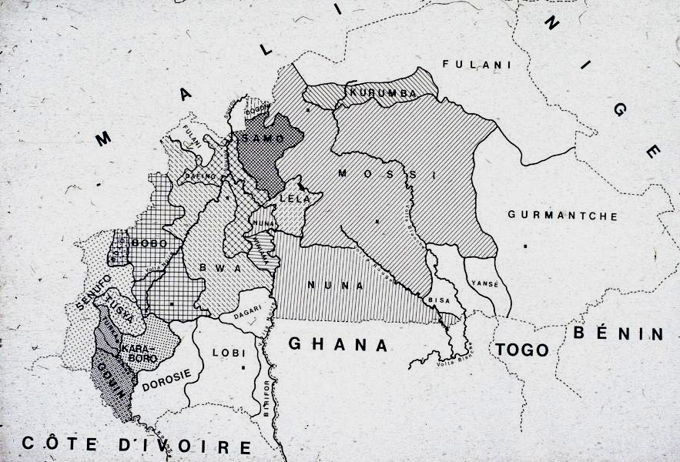

**GPS coordinates:**

**Cultural Affiliation:**

**Media:** wood, kaolin, polychrome pigments

**Dimensions:** 42.519 inches x 9.05 inches

**Weight:** 4.493 pounds

**Condition:**

**Provenance:**

**Discussion:**

**References:**